# PROJECT REPORT

1. **INTRODUCTION:**

# OVERVIEW

Techpro solution is an information technology solutions company know for helping its clients achieve their business objectives. Global in scope,we provide experience information technology and engineering professionals at the right time and the right place to meet our clients mission critical technology needs.

# PURPOSE

We are committed to achieve customer business objectives by delivering professional services & adopting innovative technologies.our mission: To channelize the knowledge, expertise and experience that has gained over the years from recommending IT product and effective solution for our customers.

1. To know how to use of Zoho books in the field of techpro solution.
2. To get the practical experience in preparing and maintaining zoho books at techpro solution.
3. To get the practical experience in getting report.
4. To get the knowledge about empathy map and brain storming map.
5. To get overall experience in zoho book a online accounting applications.
6. To get a business idea.
7. To get experiance in accounting field.

# PROBLEM DEFINITION & DESIGN THINKING

* 1. **Empathy Map**

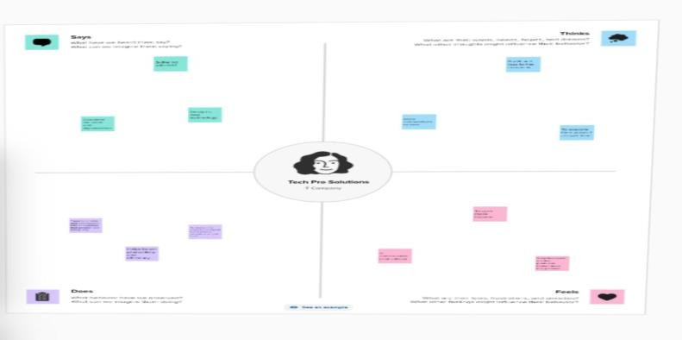

* 1. **Ideation & Brainstorming Map**

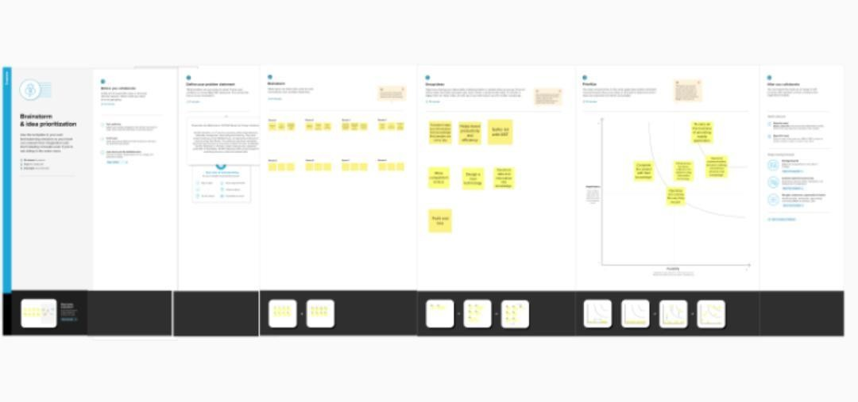

# 3 .RESULT

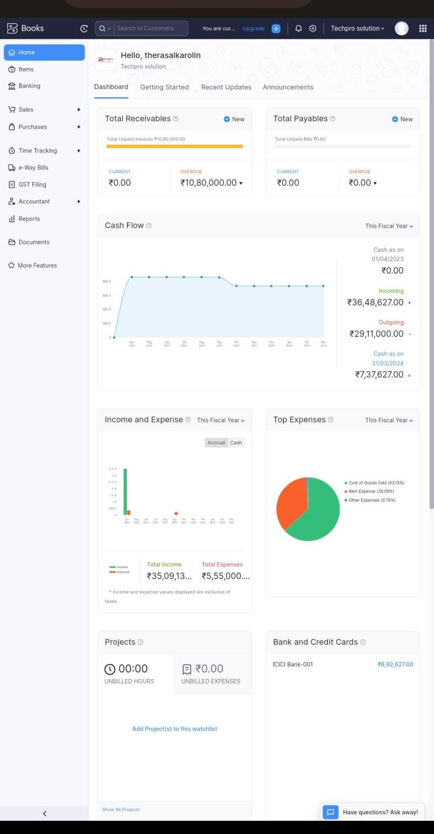

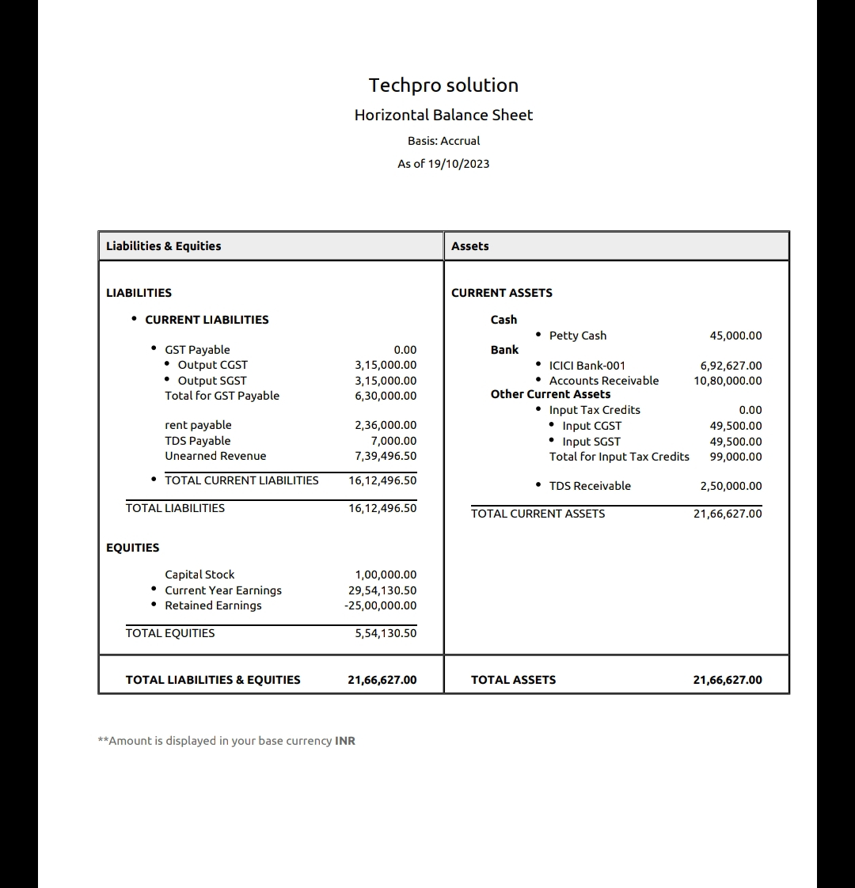

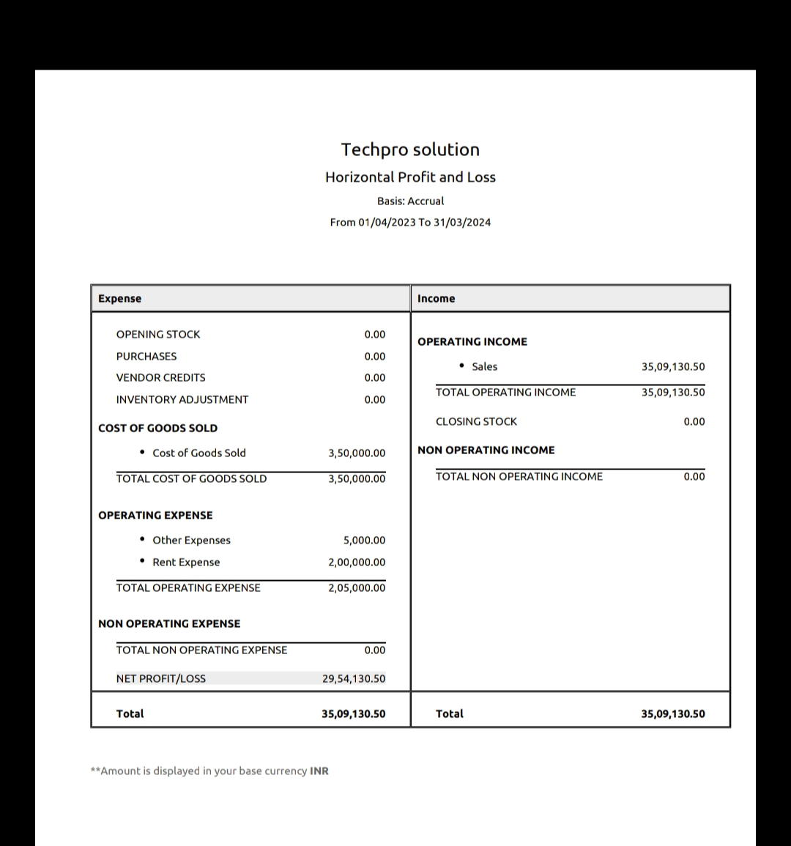

**4. ADVANTAGES & DISADVANTAGES**

Here are some advantages and disadvantages of

Advantages :

1. It is easy to use.
2. It is easy to understand
3. It is simple to use

Disadvantages:

1. Before that a practice ios need to do that.
2. Proper traning is needed

# .APPLICATIONS

There are many mainstream Zoho books App platforms that cater to but very few that provide inspiration for as well as help them share their experiences. My Trax app aims to solve this problem and provide a platform for aviod around the world.

# .CONCLUSION

In through the implementation of a comprehensive online presence strategy, techpro solution built. Choosing the server by noticing all the essential terms can help you in choosing the right one. Techpro solution is acting as the top server dealer with many experienced professionals.

# .FUTURE SCOPE

Combine cutting edge technologies with strategic expertise IT services IT technologies industries product to help customer meet their business needs. Techpro IT solutions is a leading IT solutions company in Delhi, India provides high quality responsive website designing services.